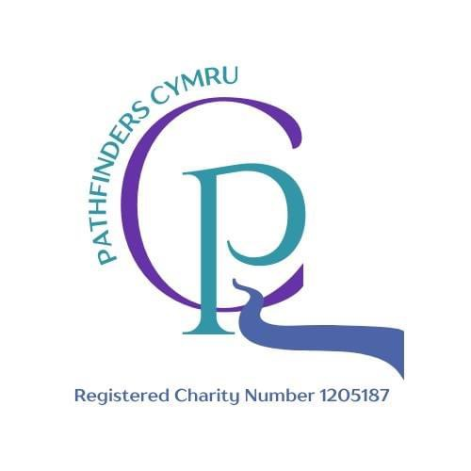

Pathfinders Cymru – AQA Unit Award Scheme Membership Terms & Conditions
These Terms & Conditions set out the agreement between Pathfinders Cymru and the individual (parent/guardian or learner aged 18+) purchasing AQA Unit Award Scheme (UAS) membership.

1. Membership Overview
- Annual membership is valid for one academic year, finishing in July.
- Membership includes:
  - Registration with AQA’s Unit Award Scheme.
  - Administration and processing of up to 4 completed units.
  - Issuing of AQA certificates for completed and verified units.
- Additional units can be added at £5 each.

2. Learner Registration
- Once payment is received, Pathfinders Cymru will issue a unique Learner ID within 10 working days.
- The Learner ID must be included in all correspondence and when submitting evidence for assessment.

3. Unit Completion
- Units may be completed through:
  - Attendance at relevant Pathfinders Cymru sessions.
  - Approved distance learning packs.
- All evidence submitted must meet the AQA assessment criteria for that unit.
- Work must be the learner’s own. Plagiarism or dishonest submissions may result in unit rejection and possible termination of membership without refund.

4. Evidence Submission
- Evidence must be submitted by the deadlines set by Pathfinders Cymru to allow verification.
- Acceptable formats include written work, photographs, videos, or scanned worksheets.
- We reserve the right to reject incomplete or unclear evidence.

5. Fees & Payments
- Membership fees are non-refundable once the learner has been registered with AQA.
- Any additional unit certificate fees are payable before assessment begins.
- Session fees for in-person activities are separate and not included in membership.

6. Certification
- Certificates are issued by AQA after successful completion and verification of units.
- Certificates will be sent to the learner’s registered address or made available for collection.

7. Behaviour & Participation
- Learners attending in-person sessions must follow Pathfinders Cymru’s Code of Conduct.
- Disruptive or unsafe behaviour may result in removal from sessions without refund.

8. Data Protection
- Personal data will be processed in line with our Privacy Policy and shared with AQA for the purposes of learner registration and certification only.

9. Changes to Membership Terms
- Pathfinders Cymru reserves the right to amend these Terms & Conditions at any time. Members will be notified of significant changes.

By purchasing membership, you agree to these Terms & Conditions.

